**Amar Gajanan Mohite**

Section – IFT562

**Arizona State University**

Instructor**:** Daniel Wells

**Activity 5- Working with AWS Lambda**

Date – 28/01/2024

In Task 2.1, take a screenshot of the "create layer" page after you add your full name to the end of the description.

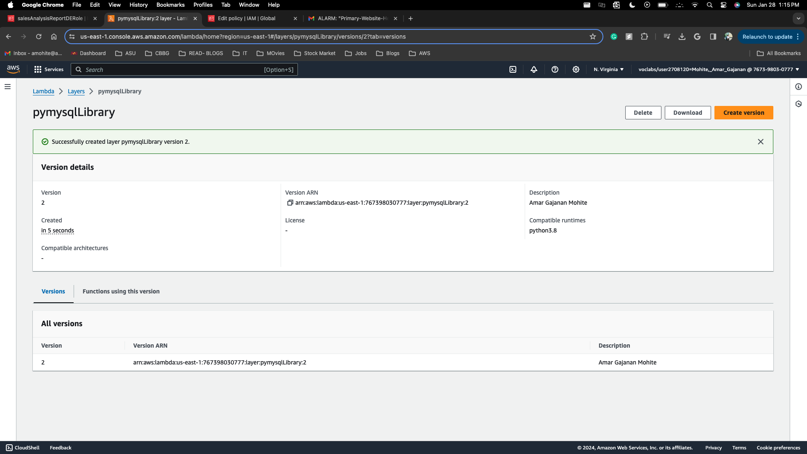

In Task 3.3, take a screenshot of the change made to troubleshoot the failing Lambda function. Make sure the change is appropriately restricted and not overly permissive! (Yes, that is a hint!)

In Task 4.2, take a screenshot of the e-mail you received. Make sure your e-mail address is visible.

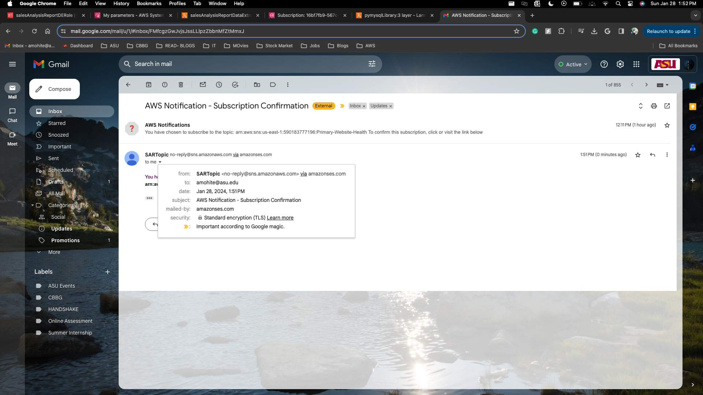

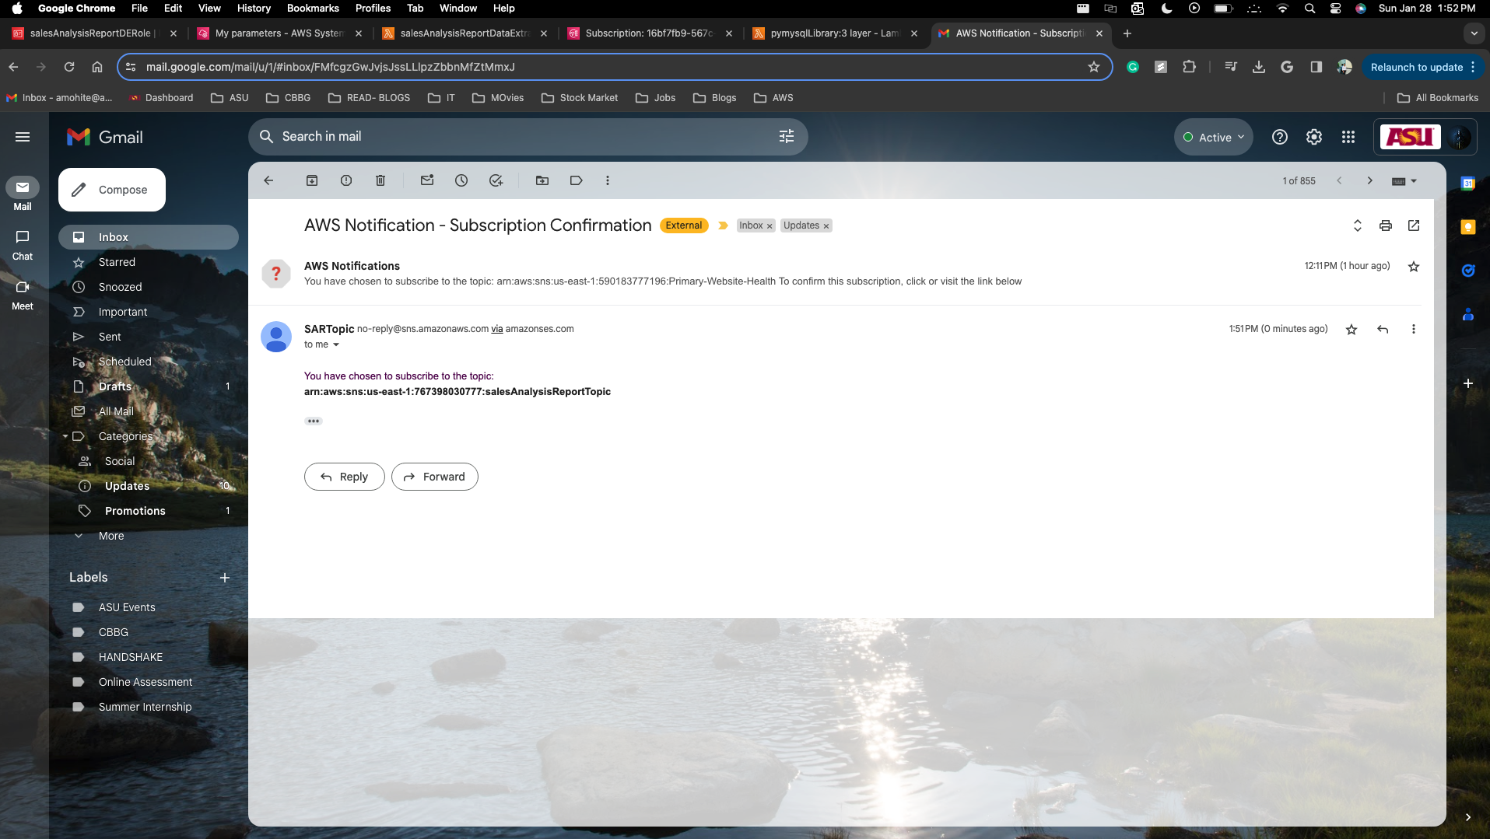

In Task 5.5, take a screenshot of the salesAnalysisReport function, make sure your name is visible in the top right corner.

In Task 5.6, take a screenshot of the e-mail you received, make sure your e-mail address is visible.

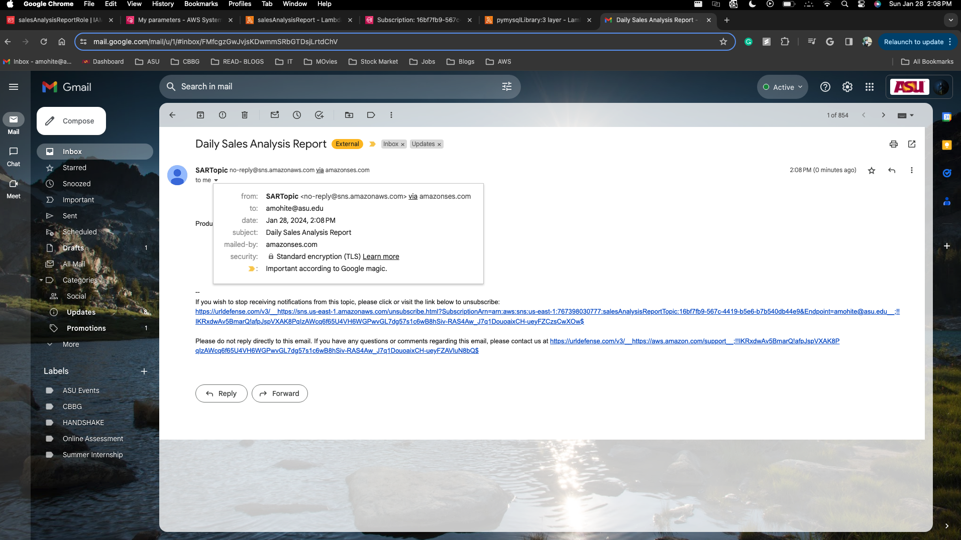

In Task 5.7, take a screenshot of the EventBridge rule you created.

